**CRASH TEST AND CONSISTENCY REPORT**

**By: Meghana S Seshasai (2021B5A72517G)**

**Anushka Sethi (2021B3A71074G)**

**Chandrika Singh Jadon (2021B1A72939G)**

**Case 1:**

**Input:**

i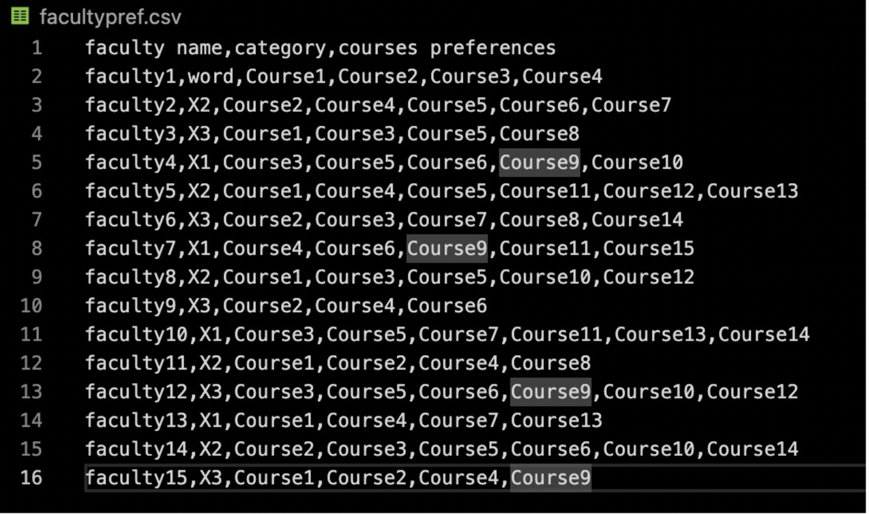

We change the category of faculty 1 to ‘word’.

**Output:**

The faculty isn’t assigned any courses.

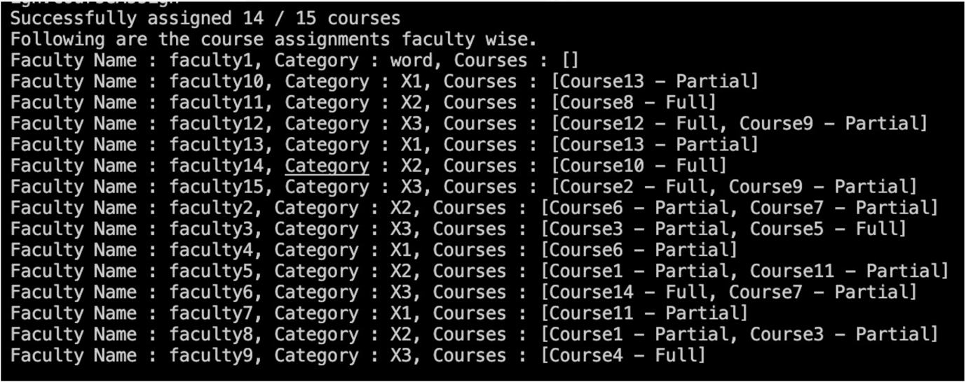

**Case 2:**

**Input:**

The preference list of faculty5 is empty.

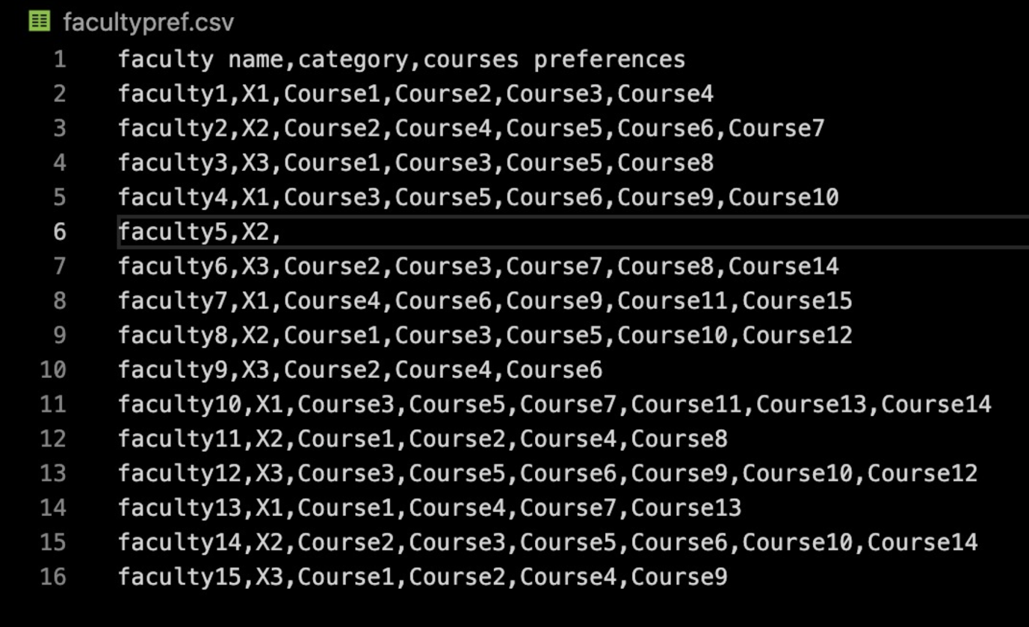

**Output:**

Faculty 5 isn’t allotted any course.

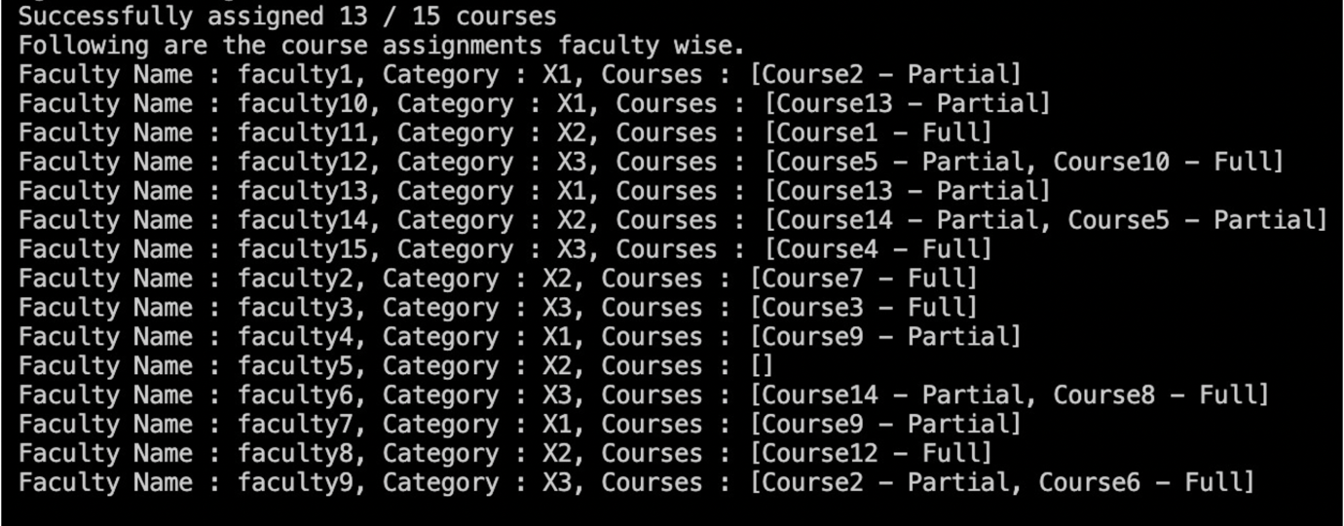

**Case 3:**

**Input:**

The csv file contains only headings, and no data.

**Output:**

No assignment is done

